Sampling strategy diagnostics: treated-side design
Global protected area effectiveness project — scoping memo

Why sampling structure matters geographically
Protected-area (PA) characteristics are not distributed uniformly across the world. Governance types in particular are geographically structured: some categories are concentrated in relatively few countries, while others are much more widely represented. IUCN categories are generally more broadly distributed, but they also vary substantially in where and how often they occur. The descriptive maps of the candidate PA population make this structure visible and show why simply drawing treated cells in proportion to PA area would not guarantee good support for comparing PA characteristics across contexts.
This motivates the sampling diagnostics that follow. The aim is not to force equal representation of countries or PA categories, but to prevent a small number of very large PAs or highly represented countries from dominating the treated sample, while preserving representation across enough distinct PAs and geographic contexts to study heterogeneity in effectiveness.
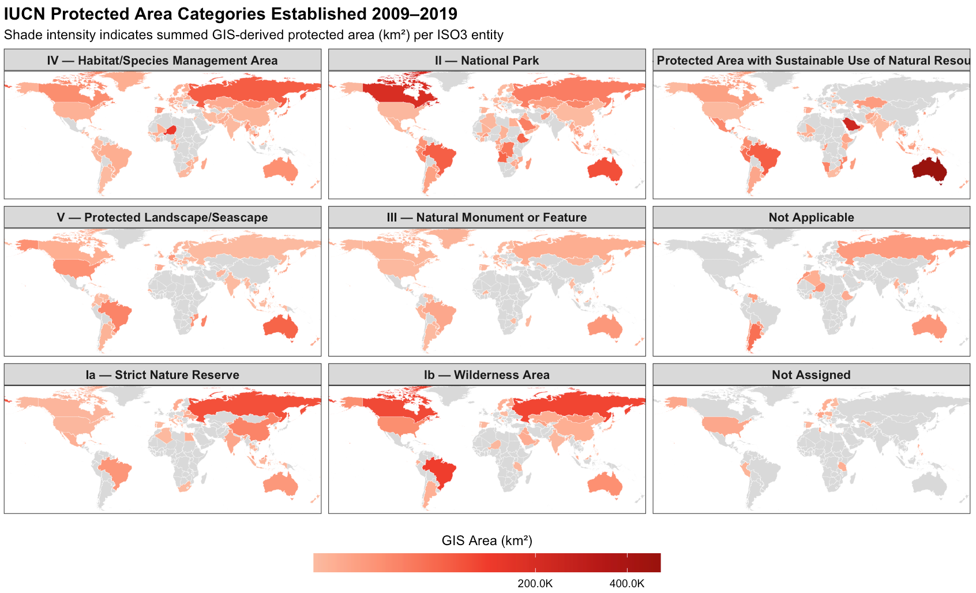
Figure S1a: Candidate PA geography by IUCN category.
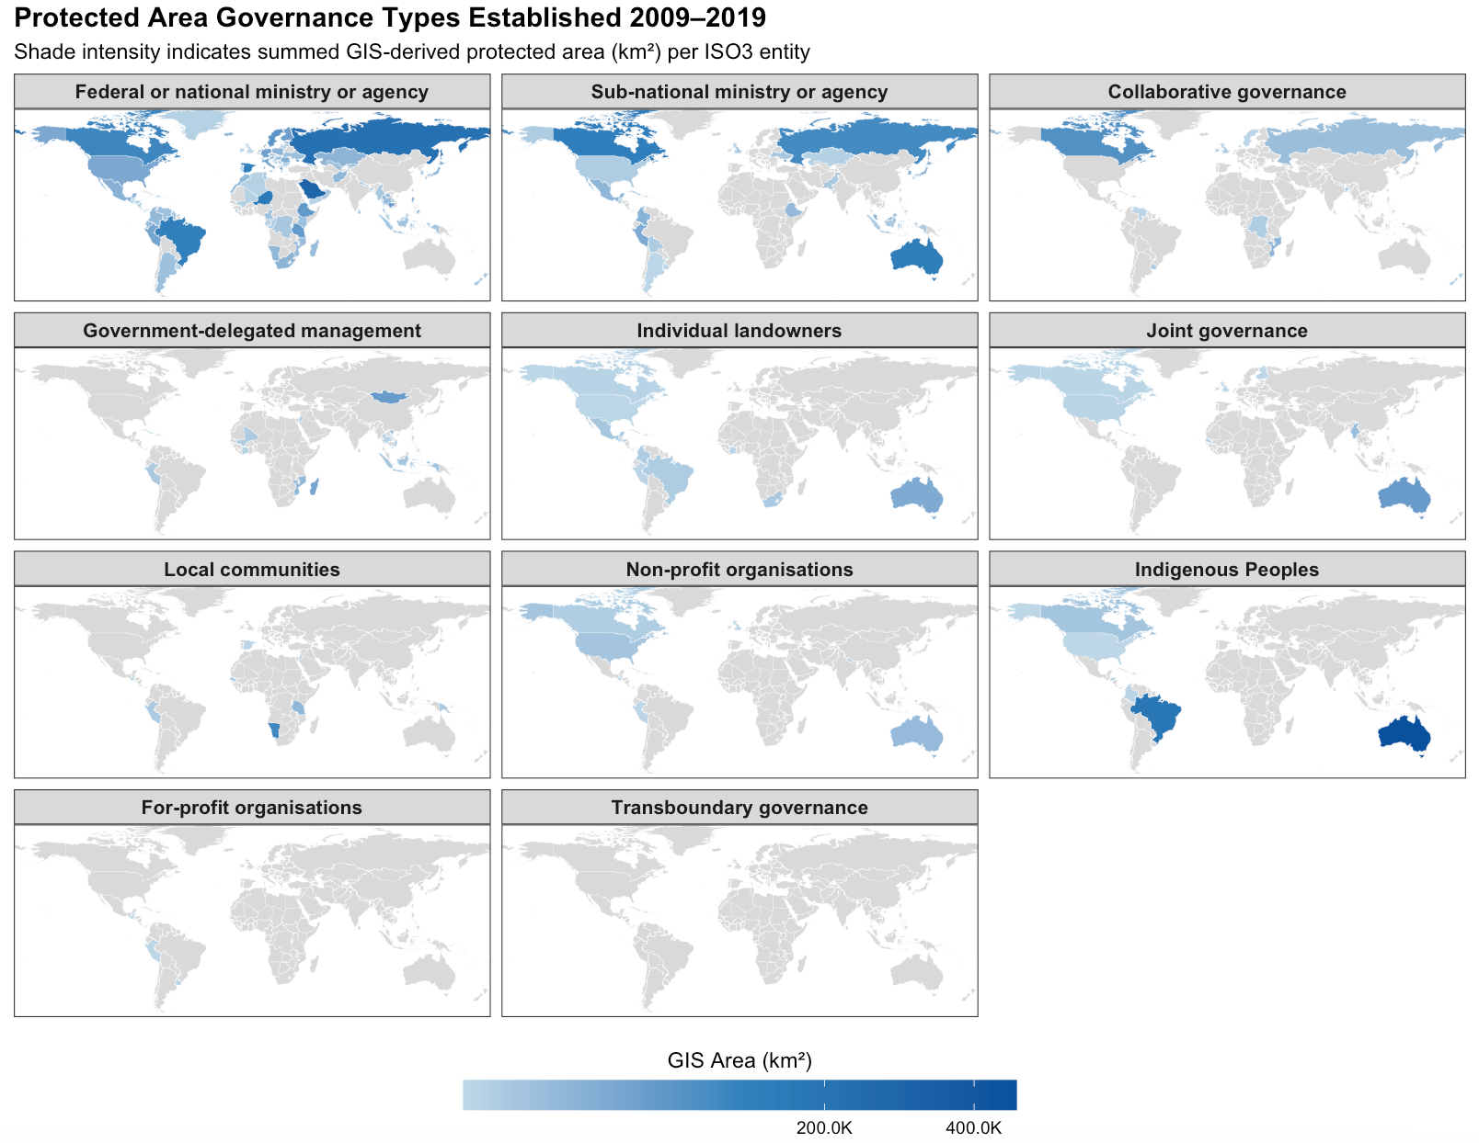
Figure S1b: Geographic distribution of candidate protected areas by governance type and IUCN category. Shading represents the summed protected-area extent within each country for PAs established during the 2009-2019 cohort window.

1. What this memo is trying to solve
The global analysis will eventually work with 1-km forest cells, but the protected-area network is extremely uneven. Some countries contain thousands of very small PAs, while a small number of very large PAs contain most of the protected area itself. If treated cells are sampled naively, a few very large PAs and countries can dominate the estimation sample. The process of thinning is used to prevent oversampling from any one geographic region but there’s a trade-off: If we thin too aggressively, we instead throw away most of the treated information in small and medium PAs. The purpose of these diagnostics is therefore practical: to construct a geographically broad treated sample that supports global estimation and HTE analysis while preserving the underlying distribution of PAs rather than imposing equal representation across countries or governance categories.
This is still a design-stage exercise. Until the actual 1-km forest/treatment grid exists, PA terrestrial area is used as a rough proxy for how many 1-km treated cells a PA could contribute. The choices below are therefore provisional and will be rechecked on the real eligible-cell frame.

Current provisional design. Primary treatment cohorts are 2009–2020; treatment begins when at least 50% of a cell is protected and is treated as absorbing thereafter; each PA can contribute at most 100 treated candidate cells; the target treated sample is approximately 250,000 cells; and each country × treatment-cohort stratum receives an initial allocation of up to 50 cells where capacity permits, with the remainder allocated approximately in proportion to each stratum’s remaining candidate-cell capacity.

2. Target population and treatment timing
The target population is terrestrial forested 1-km cells that are plausibly eligible for protection. The treated population consists of cells first protected during the primary cohort window. With outcomes beginning in 2001, starting primary cohorts in 2009 leaves eight complete pre-treatment years. Ending the main cohort window in 2020 leaves several post-treatment years for the primary analysis; later cohorts can still be used for shorter event-time analyses if useful.

For cell i, let $p_{it}$ be the fraction protected in year t. The first treatment year is
Gᵢ = min { t : $p_{it}$ ≥ 0.5 }, then $W_{it}$ = 1{ t ≥ Gᵢ }.
Where protection, $W$, is equal to 1 for the year of treatment and those following. Because the sampling design deliberately departs from simple random sampling, cell inclusion probabilities will be retained so that area-representative summaries can later be recovered by weighting.

3. First problem: PA size is extremely uneven
Before choosing a cap, thinning distance, or country allocation rule, we need to know whether the PA system is even close to balanced enough for ordinary cell sampling. It is not.

For terrestrial PAs established in 2009–2020, the WDPA metadata contain 74,850 PAs in 179 countries. The median PA is only 0.282 km². About 64.6% of PAs are smaller than 1 km², yet these account for only 0.19% of total PA area. At the other extreme, the largest 1% of PAs contain about 80% of protected area.

Diagnostic | Result
PAs / countries | 74,850 / 179
Median terrestrial PA area | 0.282 km²
PAs <1 km² | 64.6% of PAs; 0.19% of area
Largest 1% of PAs | 80.0% of terrestrial PA area
Largest 5% of PAs | 94.9% of terrestrial PA area

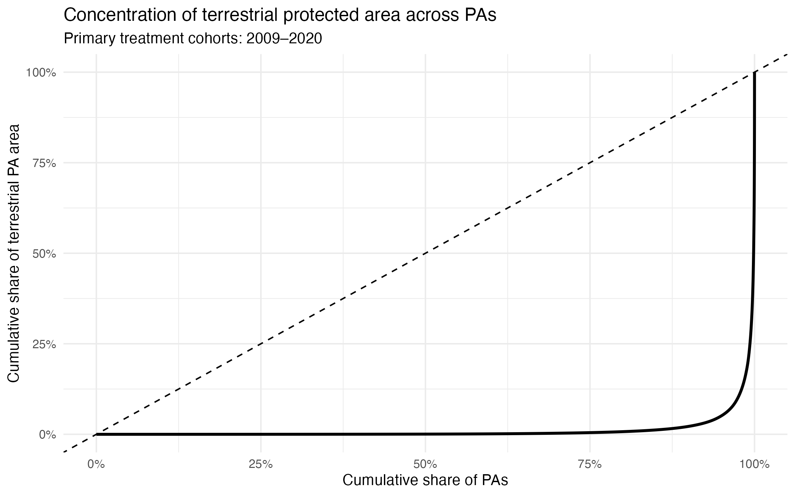Figure S2: PA-size distribution and cumulative concentration of protected area, 2009–2020 cohorts..
This immediately rules out two simple and contrasting approaches. Giving every PA equal representation would make the analysis heavily reflect the administrative fragmentation of the PA network, especially the huge number of tiny PAs. Sampling strictly in proportion to area would do the opposite and allow a small number of giant PAs to dominate. The next question is therefore how to limit spatial redundancy on the treated side without wiping out information from ordinary PAs.

4. Treated cells: blanket spatial thinning or a PA cap?
Intuition. Controls will eventually be extremely abundant, so thinning controls is relatively cheap. Treated cells are scarcer and are clustered inside PAs of very different sizes. A single minimum-distance rule applied to both sides may therefore be a poor design.

Thinning prevents sample cells from being drawn from within a fixed distance of where a previous sample was drawn. A PA-level cap would set a maximum number of cells which could be drawn from a single park for the global sample. A non-spatial proxy simulation compared 5, and 10 km thinning against PA-level caps. PA area in km² was used as a rough candidate-cell count. This is only a capacity diagnostic: park shape and the real ≥ 50%-protected forest grid will change the exact numbers.

Rule | Candidate cells | Retention | PAs with one cell | Top 1% PA share
No restriction | 4,583,976 | 100.0% | 69.6% | 79.3%
5-km thinning | 269,562 | 5.9% | 93.6% | 62.2%
10-km thinning | 119,489 | 2.6% | 97.1% | 34.8%
PA cap = 100 | 633,945 | 13.8% | 69.6% | 11.8%
PA cap = 200 | 874,765 | 19.1% | 69.6% | 17.1%

Conclusion. Blanket thinning solves the wrong problem. Five-kilometre thinning discards more than 94% of the treated-cell proxy and leaves 93.6% of PAs with one observation, while the largest PAs still dominate. A PA cap is more targeted: it leaves small and medium PAs essentially untouched and only constrains the upper tail.

The treated-side rule we carry forward is therefore simply
Nⱼ* = min(Nⱼ, K),
where Nⱼ is the number of eligible treated cells in PA j and K is the PA cap. For PAs larger than the cap, the final implementation should choose cells so that they are spatially spread across the PA rather than clustered together.

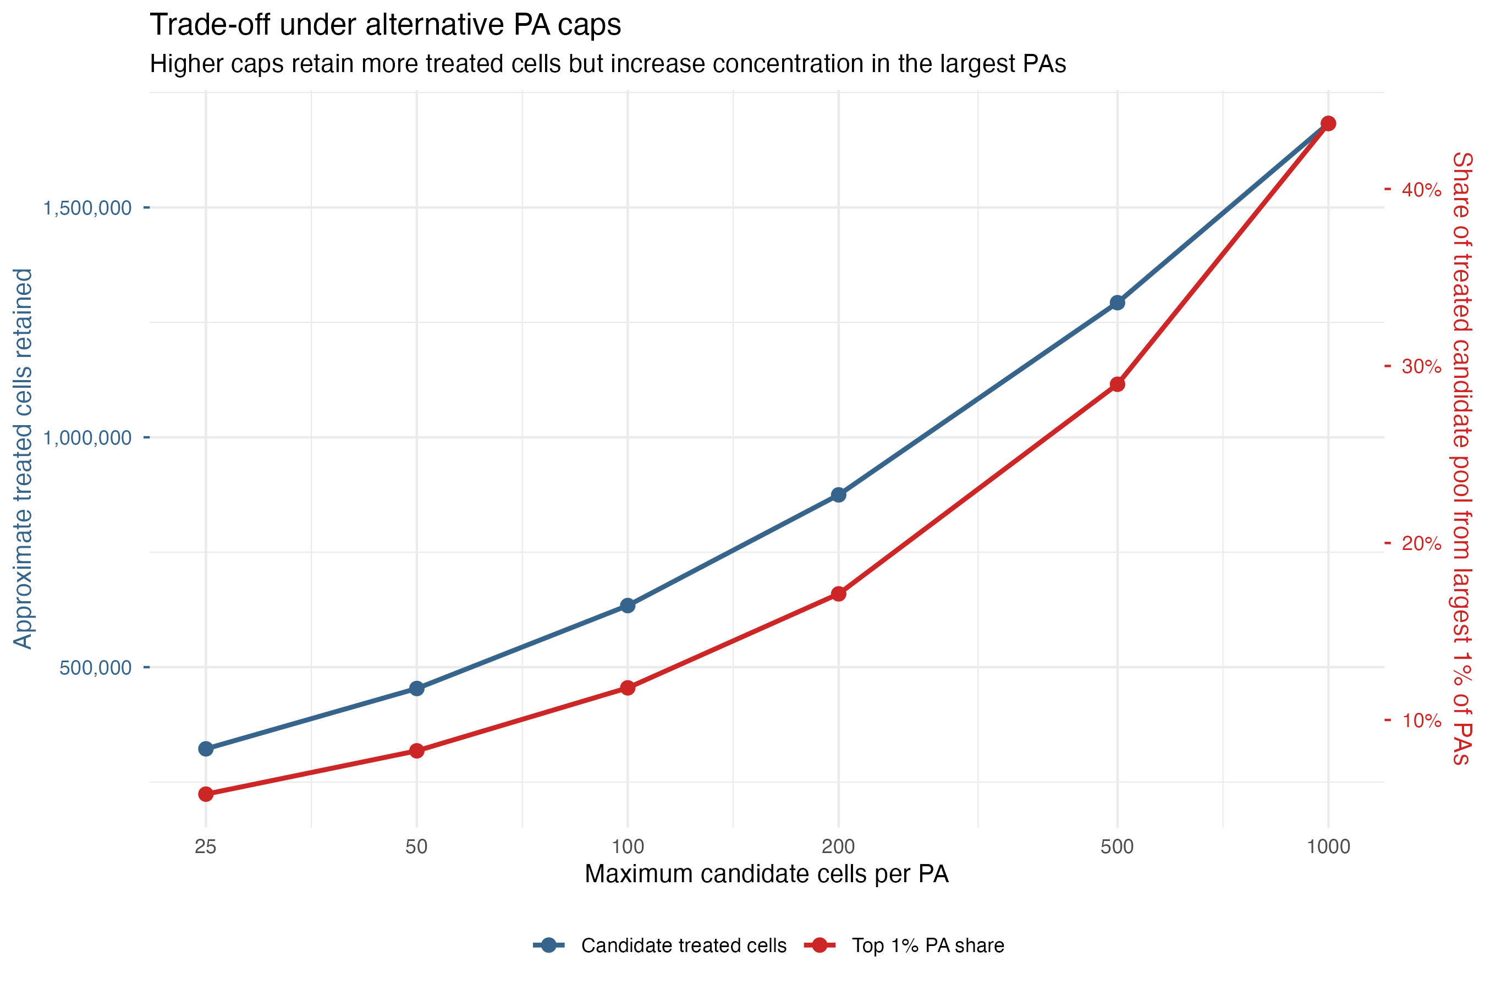
Figure S3: PA-cap sensitivity: candidate treated cells retained and the portion of cells contributed by the largest 1% of PAs.

The initial cap sensitivity identified 100–200 cells per PA as the most plausible range: lower caps discarded substantially more treated-cell capacity, while higher caps allowed large PAs to regain increasing influence over the candidate pool. The next step was therefore to test whether moving from 100 to 200 materially improved geographic, temporal, or PA-design support, rather than simply adding more cells from already large PAs.

5. Why carry forward a 100-cell PA cap?

To determine whether the additional capacity under a 200-cell cap improved representation rather than simply adding observations to already large strata, candidate treated cells were summed within each country × treatment-cohort stratum under each cap.

A country × treatment-cohort stratum groups together candidate treated cells from PAs established in the same country and treatment year. For example, treated cells from PAs established in Peru in 2012 form one stratum, while Peru 2013 forms another. We use these strata because country captures broad institutional and geographic context, while treatment cohort captures when protection begins. The goal is to prevent large countries or unusually large treatment cohorts from dominating the treated sample while retaining variation in both dimensions.

We then calculated the share of strata containing at least 50, 100, 200, and 500 candidate cells. These thresholds are diagnostic only; they are not minimum sample-size requirements. The purpose is to see whether relaxing the PA cap improves support at the lower end of the country × cohort distribution or mainly increases depth in already well-supported strata.
Country × cohort support threshold | Cap 100 | Cap 200
≥50 candidate cells | 70.8% | 70.8%
≥100 candidate cells | 64.2% | 64.2%
≥200 candidate cells | 42.1% | 56.5%
≥500 candidate cells | 25.6% | 31.2%
Share of country × cohort strata containing at least 50, 100, 200, and 500 candidate cells.

The key result is that increasing the PA cap from 100 to 200 does not increase the share of country × cohort strata reaching 50 or 100 candidate cells; the gains appear only at the higher 200- and 500-cell thresholds. This indicates that the additional capacity primarily deepens already well-supported strata rather than improving support among more weakly represented country × cohort combinations.

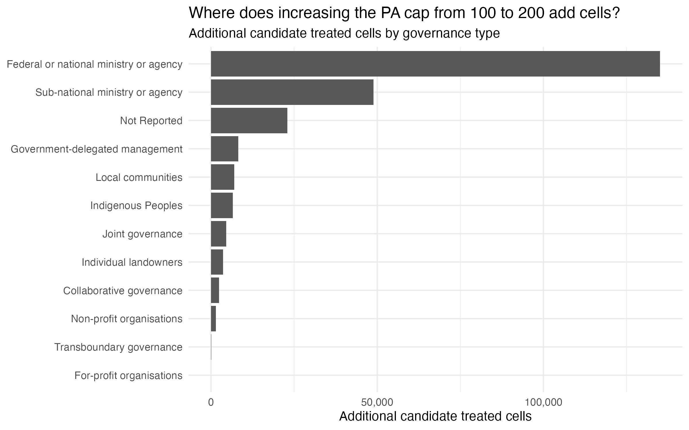

Figure S4a: Additional candidate-cell capacity from increasing the PA cap from 100 to 200, by category.

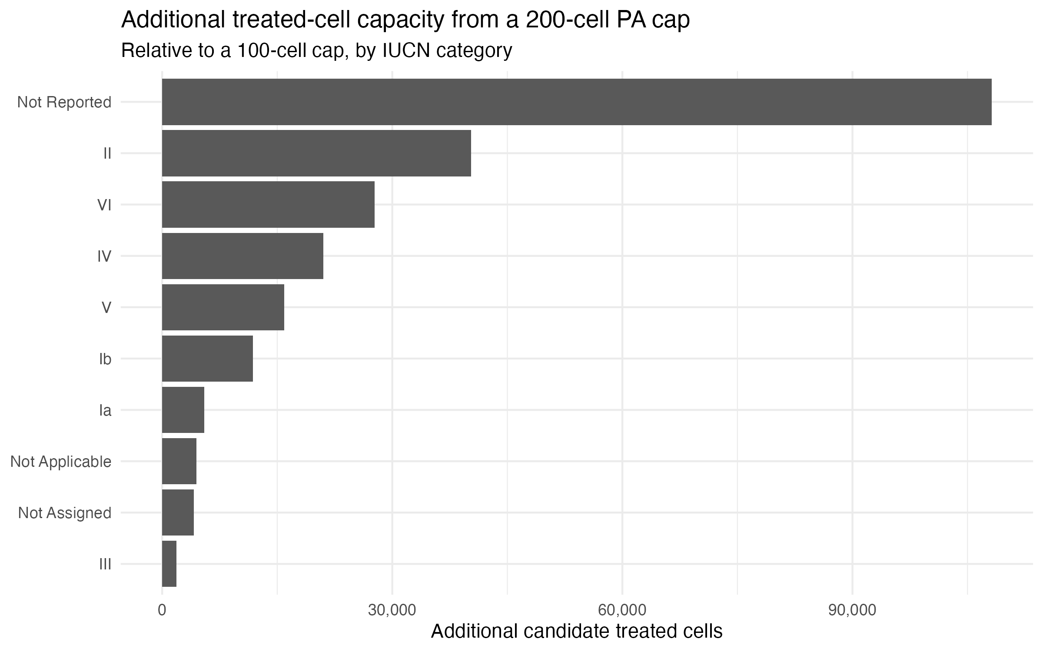
Figure S4b: Additional candidate-cell capacity from increasing the PA cap from 100 to 200 by IUCN category.

The 200-cell cap increases the candidate treated pool from about 634,000 to 875,000 cells (+38%), but it does not improve the lower end of country × cohort support at all. The gain is also concentrated: the top 10% of country × cohort strata receive 64.5% of the additional cells (Appendix Table A2.1). Governance and IUCN checks told the same story: the additional capacity largely accrues to already common or large categories rather than broadening representation across distinct PAs and countries.

Provisional decision. Use K = 100. It sharply reduces dominance by giant PAs while retaining a large treated candidate pool. Revisit this after constructing the actual forested ≥ 50%-protected grid.

6. Second problem: how to spread the treated sample across countries and cohorts
The cap prevents a single PA from dominating, but it does not stop large countries or well-represented treatment years from taking most of the remaining sample. We therefore need a second allocation stage across country × treatment-cohort strata.

After the 100-cell cap there are 1,028 country × cohort strata in 179 countries and about 633,945 candidate treated cells (Appendix Table A2.2). We compared treated targets of 200k, 250k and 300k, and minimum stratum allocations of 0, 25, 50 and 100 cells.

The allocation is intentionally hybrid. If Cₕ is the candidate capacity of stratum h, the design first gives the stratum up to 50 cells where available, bₕ = min(Cₕ, 50). The remaining treated target is then distributed approximately in proportion to each stratum’s remaining capacity. The goal is not equal country-year samples; it is to stop small strata from disappearing while still letting the sample broadly reflect where treated cells actually exist.

250k treated design | Strata represented | Median cells / stratum | Strata ≥ 100 | Top 5 countries
Proportional | 90.6% | 46.5 | 36.4% | 31.1%
Minimum 25 | 100% | 60 | 38.1% | 29.8%
Minimum 50 | 100% | 74 | 42.6% | 28.6%
Minimum 100 | 100% | 105.5 | 64.2% | 26.3%
How much minimum representation should each country × treatment-cohort stratum receive without overbalancing the sample?

Pure proportional allocation loses some smaller countries and cohorts. A minimum of 25 is enough to keep all 1,028 strata and all 179 countries in the sample. Moving to 50 gives more useful depth while still preserving substantial proportionality. A 100-cell minimum increases the share of strata with at least 100 sampled cells from 42.6% to 64.2%, but this increase is largely built into the allocation rule: every stratum with at least 100 candidate cells is deliberately pushed to that threshold. Because all countries and country × cohort strata were already represented under smaller minimums, the 100-cell rule adds sampling depth rather than new geographic or treatment-timing coverage. We therefore adopt a 50-cell minimum and carry this forward as the provisional allocation rule for the treated sample.

The same sensitivity is shown graphically below. Increasing the minimum allocation reduces country concentration and improves support in smaller strata, while increasing the overall treated target adds depth but partially restores concentration in the largest countries.

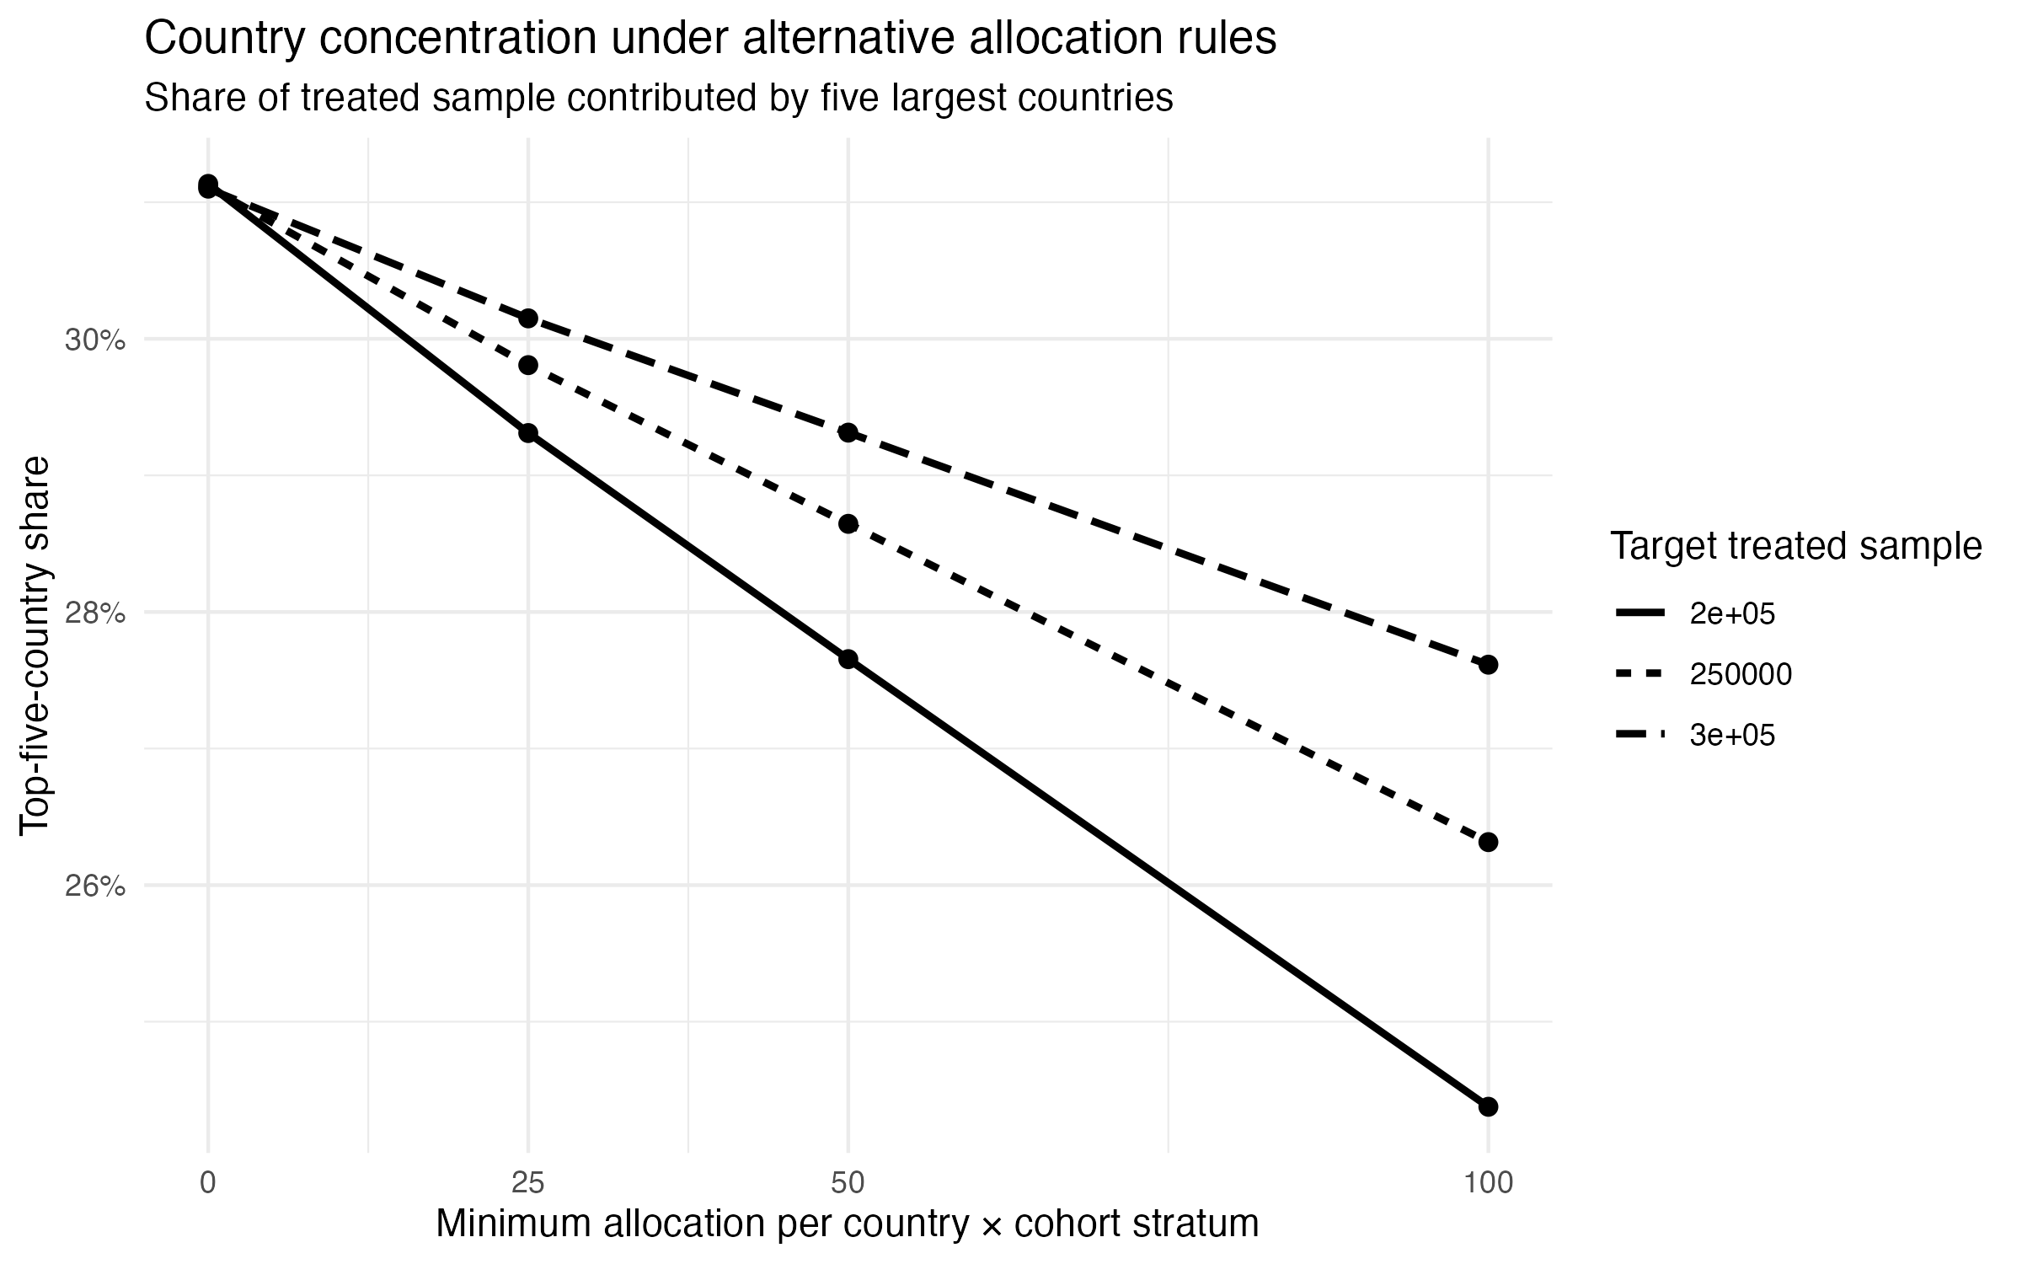
Figure S5a: Country × cohort allocation sensitivity: support and top-five-country concentration across minimum allocations and treated target

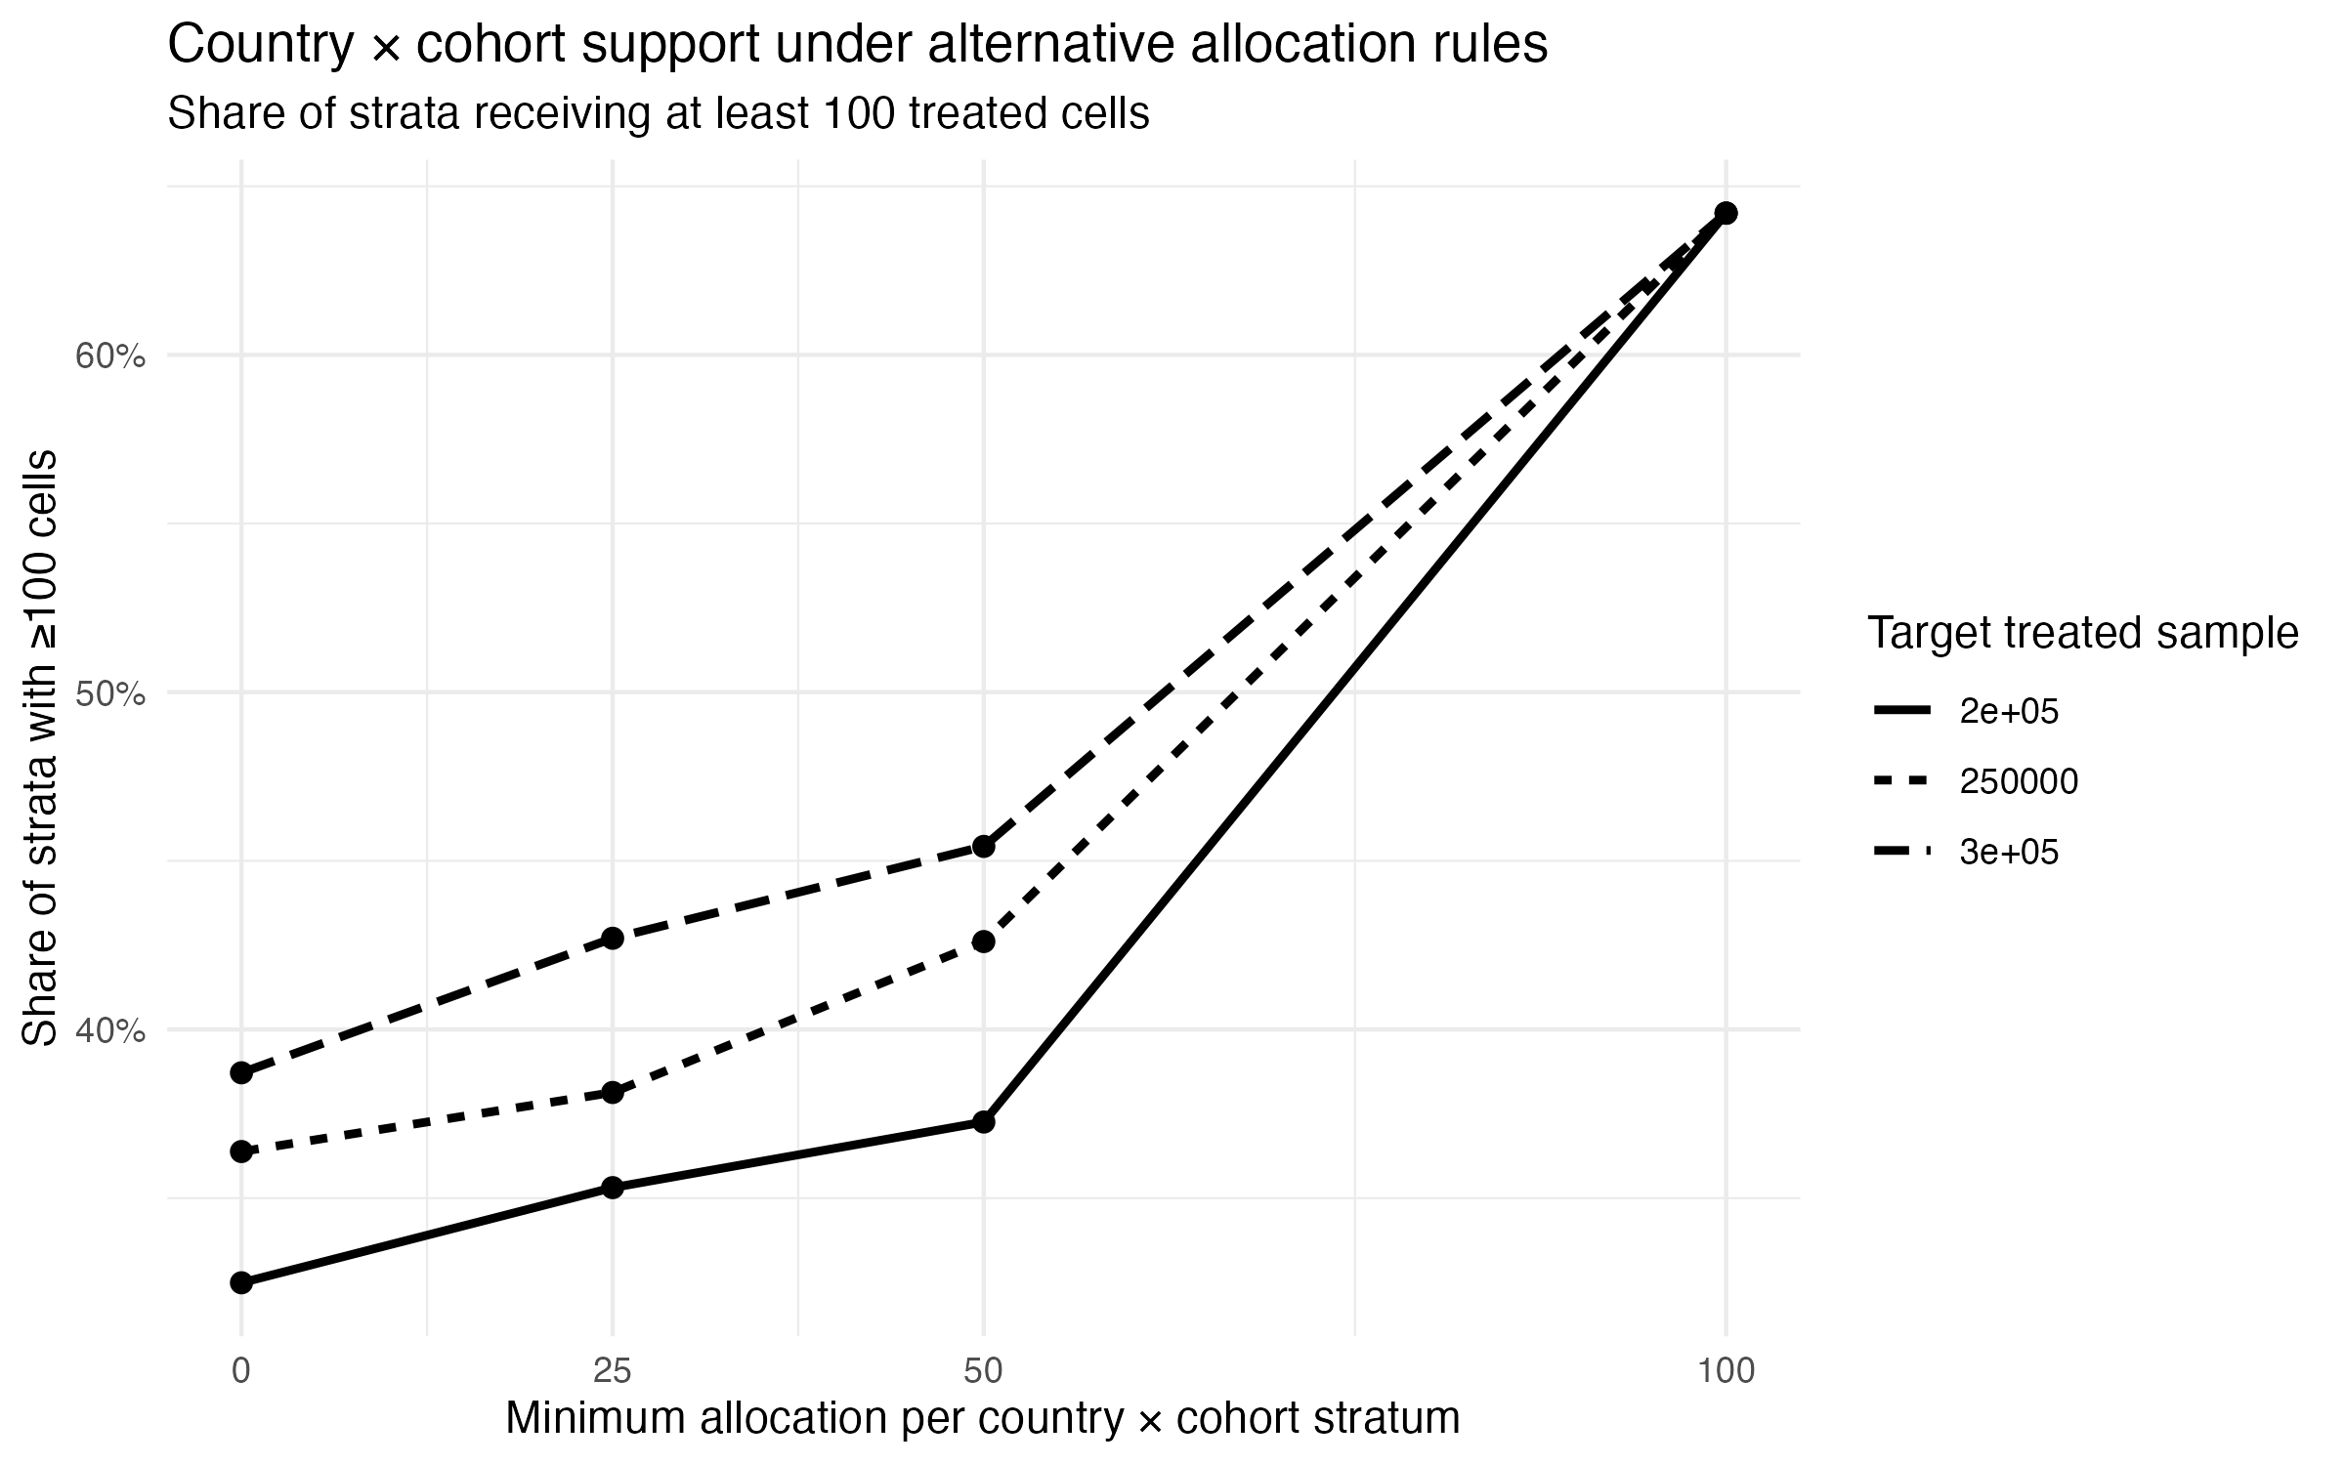
Figure S5b: Country × cohort allocation sensitivity: support and top-five-country concentration across minimum allocations and treated targets.

Treated target | Median cells / stratum | Strata ≥100 cells | Strata ≥200 cells | Top 5 countries
200k | 68 | 37.3% | 22.4% | 27.7%
250k | 74 | 42.6% | 26.6% | 28.6%
300k | 80 | 45.4% | 29.6% | 29.3%
How large should the treated sample be overall?

With the 50-cell minimum fixed, increasing the treated target from 200,000 to 250,000 raises the share of country × cohort strata with at least 100 treated cells from 37.3% to 42.6%, while a further increase to 300,000 raises this share to 45.4%. Support at the 200-cell threshold similarly increases from 22.4% to 26.6% to 29.6%. Thus, although larger samples continue to improve within-stratum depth, the additional 50,000 cells beyond 250,000 produce relatively modest gains in these support metrics while increasing the size of the analysis by a further 20%. We therefore carry forward 250,000 treated cells as a pragmatic provisional compromise between stratum depth and computational burden, rather than as an empirically optimal sample size. This choice will be revisited once the actual eligible-cell and control pools are constructed.

Provisional decision. Carry forward a treated target of about 250,000 cells, with a minimum allocation of up to 50 cells per country × cohort where capacity permits, followed by proportional allocation of the remainder.

7. Does the provisional treated sample support governance and IUCN questions?
The sampling rules above were chosen to control geography and PA-size dominance, not to balance governance or IUCN categories. Before adding any category-specific oversampling, we therefore check whether the resulting treated sample retains enough independent PAs and countries for governance, and IUCN-related analyses.

Within each country × cohort stratum, we can estimate how many cells each PA contributes on average under random sampling. More importantly, we can calculate the probability that a PA contributes at least one sampled cell. If a stratum contains Nₕ candidate cells, PA j contributes Nⱼ of them, and mₕ cells are sampled, then
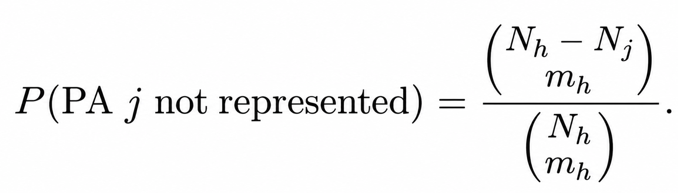
Where the denominator is the total number of possible samples of size mₕ, while the numerator asks how many of those samples contain zero cells from PA j.
This matters because 5,000 cells from 50 PAs are not the same kind of support as 5,000 cells from 5 PAs. For governance effects, independent PA and country replication are potentially more informative than raw cell counts.

Governance type | Candidate PAs | Expected sampled PAs | Expected sampled cells
Federal/national | 53,862 | 28,945 | 159,646
Sub-national | 11,390 | 6,936 | 45,525
Indigenous Peoples | 119 | 115 | 3,148
Local communities | 180 | 175 | 4,146
Government-delegated | 181 | 175 | 5,039
Collaborative governance | 302 | 211 | 2,720
Joint governance | 179 | 146 | 2,745
Expected governance representation under the provisional treated-sampling design. Candidate PAs are the PAs available in the 2009–2020 treatment cohorts. Expected sampled PAs and cells are calculated under a 100-cell PA cap, a treated-sample target of 250,000 cells, and a minimum allocation of up to 50 cells per country × treatment-cohort stratum.

The cell sample is obviously dominated by federal/national and sub-national PAs, but several rarer governance types retain most of the PAs that actually exist in the candidate population. For example, the design is expected to include about 115 of 119 Indigenous-governed PAs and 175 of 180 local-community PAs. Oversampling thousands of additional cells from those same PAs would make the cell counts look more balanced without creating much new independent governance information.
IUCN categories generally have broader PA and country replication. The main issue is missing classification: about 45.5% of expected treated cells fall in “Not Reported” for IUCN category (Appendix Table A2.3). Those observations remain useful for the protected-versus-unprotected analysis, but not for category-specific contrasts.

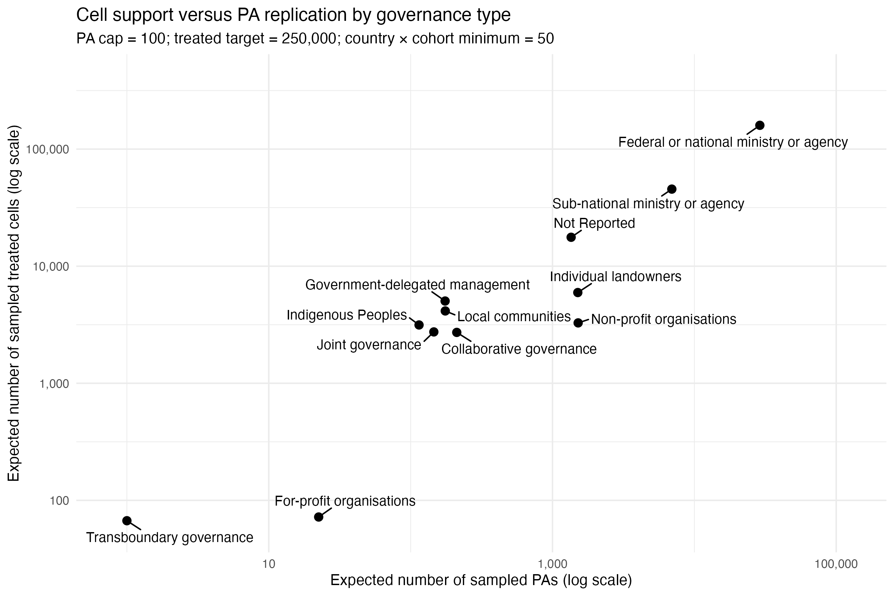

Figure S6: Cell support versus expected distinct PA-level replication by governance type.

8. Do PA design categories overlap enough to support causal comparisons?
The previous diagnostic asked whether the provisional treated sample retains enough PAs and countries within each governance and IUCN category. That is necessary, but not sufficient, for estimating heterogeneity by PA design. A governance or IUCN category may contribute many sampled PAs and cells but still be difficult to compare if it occurs in geographic contexts where no alternative PA designs are observed. In that case, differences associated with PA design may be difficult to separate from broader differences between countries.
We therefore first ask a broad support question: when a PA-design category occurs in a country, are alternative reported categories also observed in that country? This is more relevant to the present sampling decision than requiring any particular pairwise comparison, because the specific governance and IUCN contrasts to be estimated have not yet been fixed.
For governance, several policy-relevant categories have substantial within-country alternative support. Indigenous Peoples governance has alternative reported governance regimes in all 6 countries where it occurs; joint governance in all 12; individual landowners in all 14; collaborative governance in 17 of 20; sub-national governance in 18 of 22; local communities in 10 of 14; and government-delegated management in 12 of 17 (Appendix Tables A2.4–A2.5). These results indicate that the presence of rarer governance categories does not generally imply an absence of alternative governance arrangements within the same countries.
IUCN categories show broader within-country overlap: approximately 86–98% of countries containing each reported IUCN category also contain at least one alternative reported category (Appendix Table A2.6).
Overlap is substantially weaker when the comparison is restricted to the exact country × treatment-cohort stratum. Only 22.5% of eligible governance strata contain at least two reported governance types, compared with 52.5% for IUCN categories (Appendix Table A2.7). Requiring all design comparisons to occur within the same country and treatment cohort would therefore discard substantial information, particularly for governance. Treatment timing will instead need to be handled explicitly in the causal design, with geographic and covariate overlap used to define appropriate comparison domains.
Specific pairwise contrasts are a later-stage question. Appendix Tables A2.8–A2.9 report how often particular pairs of governance and IUCN categories co-occur within countries. These diagnostics can be revisited once the substantive contrasts of interest are defined, to determine which comparisons have adequate empirical support and where comparison domains may need to be restricted. They are not used here to determine the general treated-sampling rule.
Implication for the sampling design. These results do not justify adding a general governance/IUCN oversampling stage. For several rare categories, most available independent PAs are already expected to enter the sample, and alternative PA designs are present in many of the same countries. Adding more cells from those PAs would therefore do relatively little to improve independent support. The more important question for later modeling is whether the specific contrasts ultimately estimated have adequate overlap in country and covariate space.
Decision. Do not add a general governance/IUCN oversampling stage at this point.

9. Provisional treated-side sampling algorithm
The current treated-side design can therefore be summarized in a fairly simple sequence:
- Build the actual terrestrial 1-km forest eligibility frame and identify first treatment year using the ≥ 50%-protected rule for the 2009–2020 primary cohorts.
- Treat protection as absorbing for the main binary analysis, while retaining governance, IUCN, ownership/designation, and later category changes separately.
- Within each PA, keep all eligible treated cells if there are 100 or fewer. If there are more than 100, select 100 cells using a spatially balanced design and retain their inclusion probabilities.
- Aggregate the capped treated candidate pool to country × treatment-cohort strata.
- Give each stratum up to 50 treated cells where available, then allocate the remaining treated target approximately in proportion to residual capacity until the treated sample reaches about 250,000 cells.
- Retain PA identity, country/cohort identifiers, and the full sampling probabilities so the estimation sample can later be reweighted to population-relevant summaries.
The important point is that these rules are not intended to make the sample “balanced” in the ordinary descriptive sense. They are intended to stop a small number of large PAs and countries from determining the model while preserving the real structure of the treated population.

10. Next step
At this point the treated side is specified well enough to stop tuning WDPA-only simulations. We have a provisional answer to the main treated-sampling questions: how to handle PA size, how much to retain from large PAs, how to preserve small country/cohort strata, and whether governance/IUCN need their own oversampling layer.
What WDPA metadata cannot tell us is whether those treated cells have credible counterfactuals. A country × cohort stratum can contain 100 well-sampled treated cells and still be useless for causal identification if there are very few plausible never-treated or not-yet-treated forest cells nearby or within comparable covariate support.
Next data step. Construct a preliminary global 1-km sampling frame containing country, baseline forest eligibility, annual protected fraction / first treatment year, never-treated and not-yet-treated status by cohort, PA identity, and distance to PA boundaries.
Then quantify, for every treated country × cohort:
· How many never-treated and not-yet-treated forest cells are available;
· How much of that pool survives a same-country comparison rule;
· How much is lost when untreated cells close to PA boundaries are excluded or separated for the spillover analysis;
· How aggressively controls can be spatially thinned without losing support; and
· Where broader regional controls or stronger common-support restrictions may be needed.

Appendix 1. Current decision log
Question | Current choice | Why / when to revisit
Primary cohort window | 2009–2020 | Allows long pre-treatment history and several post-treatment years; revisit with final outcome series.
Treated spatial redundancy | No blanket thinning | Blanket 5–10 km thinning discards too much treated information.
PA cap | 100 treated cells / PA | Large reduction in PA dominance; revisit with actual eligible-cell counts and shapes.
Primary treated strata | Country × cohort | Maintains geographic/institutional and treatment-timing representation.
Treated allocation | ≈ 250k; minimum up to 50 / stratum | Keeps all strata/countries represented without forcing near-equal country-year samples.
Governance / IUCN augmentation | None for now | Most rare categories already retain much of their independent PA support; overlap matters more than cell balance.
Controls | Next diagnostic | Need the actual 1-km forest/treatment frame before credible control availability can be assessed.

Appendix 2.
Table A2.1. Concentration of additional candidate-cell capacity from increasing the PA cap from 100 to 200
Top 1% of country × cohort strata | Top 5% of country × cohort strata | Top 10% of country × cohort strata
17.90% | 46.80% | 64.50%

Table A2.2. Country × treatment-cohort candidate capacity after applying the 100-cell PA cap
Country × cohort strata | Countries | Candidate treated cells | Median candidate cells / stratum | 10th percentile | 90th percentile
1028 | 179 | 633945 | 119.5 | 3 | 1662.6

Table A2.3. Expected IUCN representation under the provisional treated-sampling design
IUCN category | Candidate PAs | Expected sampled PAs | Candidate countries | Expected sampled countries | Expected sampled cells | Share of treated sample
Not Reported | 19,790 | 13,132 | 115 | 114.8 | 113,660 | 45.5%
IV | 27,666 | 13,338 | 105 | 104.6 | 37,398 | 15.0%
II | 1,275 | 1,117 | 88 | 88 | 25,300 | 10.1%
VI | 2,374 | 1,650 | 66 | 65.6 | 20,608 | 8.2%
V | 5,098 | 2,979 | 53 | 53 | 18,357 | 7.3%
Ib | 871 | 668 | 39 | 38.4 | 9,794 | 3.9%
Not Assigned | 10,431 | 4,410 | 22 | 21.8 | 8,846 | 3.5%
Ia | 5,331 | 2,584 | 41 | 40.3 | 8,491 | 3.4%
III | 1,940 | 1,153 | 54 | 51.9 | 4,516 | 1.8%
Not Applicable | 74 | 72 | 46 | 46 | 3,030 | 1.2%

Table A2.4. Within-country overlap among PA governance types
Governance type | Countries present | Countries with alternative governance | % countries with alternative governance | Expected sampled PAs | % sampled PAs in overlap countries | Median expected alternative PAs in same country
For-profit organizations | 4 | 4 | 100.0% | 22 | 100.0% | 42.7
Indigenous Peoples | 6 | 6 | 100.0% | 115 | 100.0% | 1094
Joint governance | 12 | 12 | 100.0% | 146 | 100.0% | 9.8
Individual landowners | 14 | 14 | 100.0% | 1,508 | 100.0% | 108.1
Collaborative governance | 20 | 17 | 85.0% | 211 | 90.1% | 15.8
Non-profit organizations | 12 | 10 | 83.3% | 1,516 | 99.5% | 77.8
Sub-national ministry or agency | 22 | 18 | 81.8% | 6,936 | 97.3% | 33.9
Local communities | 14 | 10 | 71.4% | 175 | 89.7% | 5.5
Government-delegated management | 17 | 12 | 70.6% | 175 | 56.2% | 5
Federal or national ministry or agency | 123 | 45 | 36.6% | 28,945 | 31.3% | 0
Transboundary governance | 1 | 0 | 0.0% | 1 | 0.0% | 0
A2.4 asks: does this governance type occur in countries that contain any alternative governance?

Table A2.5. Strength of alternative-governance support within countries
Governance type | Countries present | At least 1 alternative PAs | At least 5 alternative PAs | At least 10 alternative PAs | At least 25 alternative PAs
Federal or national ministry or agency | 123 | 43 | 24 | 19 | 17
Sub-national ministry or agency | 22 | 18 | 15 | 14 | 12
Collaborative governance | 20 | 17 | 15 | 14 | 8
Government-delegated management | 17 | 12 | 9 | 5 | 2
Individual landowners | 14 | 14 | 12 | 10 | 10
Local communities | 14 | 10 | 7 | 6 | 5
Joint governance | 12 | 12 | 9 | 6 | 5
Non-profit organizations | 12 | 10 | 9 | 8 | 8
Indigenous Peoples | 6 | 6 | 6 | 6 | 5
For-profit organizations | 4 | 4 | 3 | 2 | 2
Transboundary governance | 1 | 0 | 0 | 0 | 0

Table A2.6. Within-country overlap among IUCN categories
IUCN category | Countries present | Countries with alternative IUCN category | % countries with alternative IUCN category | Expected sampled PAs | % sampled PAs in overlap countries | Median expected alternative PAs in same country
II | 88 | 77 | 87.5% | 1,117 | 98.2% | 10.2
III | 54 | 52 | 96.3% | 1,153 | 99.8% | 39.6
IV | 105 | 91 | 86.7% | 13,338 | 99.7% | 7
Ia | 41 | 38 | 92.7% | 2,584 | 99.8% | 36.9
Ib | 39 | 36 | 92.3% | 668 | 99.4% | 22
V | 53 | 52 | 98.1% | 2,979 | 99.7% | 38
VI | 66 | 57 | 86.4% | 1,650 | 96.9% | 9.8

Table A2.7. Governance and IUCN diversity within country × treatment-cohort strata
PA design characteristic | Country × cohort strata | Strata with ≥2 categories | Strata with ≥3 categories | Median categories / stratum
Governance type | 892 | 22.5% | 7.8% | 1
IUCN category | 789 | 52.5% | 28.0% | 2
*Excludes "Not Reported", "Not Assigned", and "Not Applicable"

Table A2.8a. Pairwise within-country overlap among PA governance types
Governance type A | Governance type B | Countries containing both
Collaborative governance | Federal or national ministry or agency | 15
Federal or national ministry or agency | Sub-national ministry or agency | 14
Federal or national ministry or agency | Individual landowners | 11
Federal or national ministry or agency | Government-delegated management | 9
Federal or national ministry or agency | Joint governance | 8
Federal or national ministry or agency | Local communities | 8
Federal or national ministry or agency | Non-profit organizations | 8
Individual landowners | Sub-national ministry or agency | 8
Non-profit organizations | Sub-national ministry or agency | 7
Indigenous Peoples | Individual landowners | 6
Individual landowners | Non-profit organizations | 6
Collaborative governance | Sub-national ministry or agency | 5
Federal or national ministry or agency | Indigenous Peoples | 5
Individual landowners | Joint governance | 5
Collaborative governance | Non-profit organizations | 4
Indigenous Peoples | Sub-national ministry or agency | 4
Joint governance | Non-profit organizations | 4
Joint governance | Sub-national ministry or agency | 4
Collaborative governance | Government-delegated management | 3
Collaborative governance | Joint governance | 3
Federal or national ministry or agency | For-profit organizations | 3
For-profit organizations | Sub-national ministry or agency | 3
Indigenous Peoples | Joint governance | 3
Indigenous Peoples | Non-profit organizations | 3
Individual landowners | Local communities | 3
Local communities | Sub-national ministry or agency | 3
Collaborative governance | Individual landowners | 2
For-profit organizations | Individual landowners | 2
For-profit organizations | Local communities | 2
For-profit organizations | Non-profit organizations | 2
Government-delegated management | Individual landowners | 2
Government-delegated management | Local communities | 2
Government-delegated management | Non-profit organizations | 2
Government-delegated management | Sub-national ministry or agency | 2
Joint governance | Local communities | 2
Local communities | Non-profit organizations | 2
Collaborative governance | For-profit organizations | 1
Collaborative governance | Indigenous Peoples | 1
For-profit organizations | Government-delegated management | 1
Government-delegated management | Joint governance | 1
Indigenous Peoples | Local communities | 1
A2.8a asks: which specific governance pairs co-occur, and in how many countries?

A2.8b. Within-country overlap heatmaps for governance type.
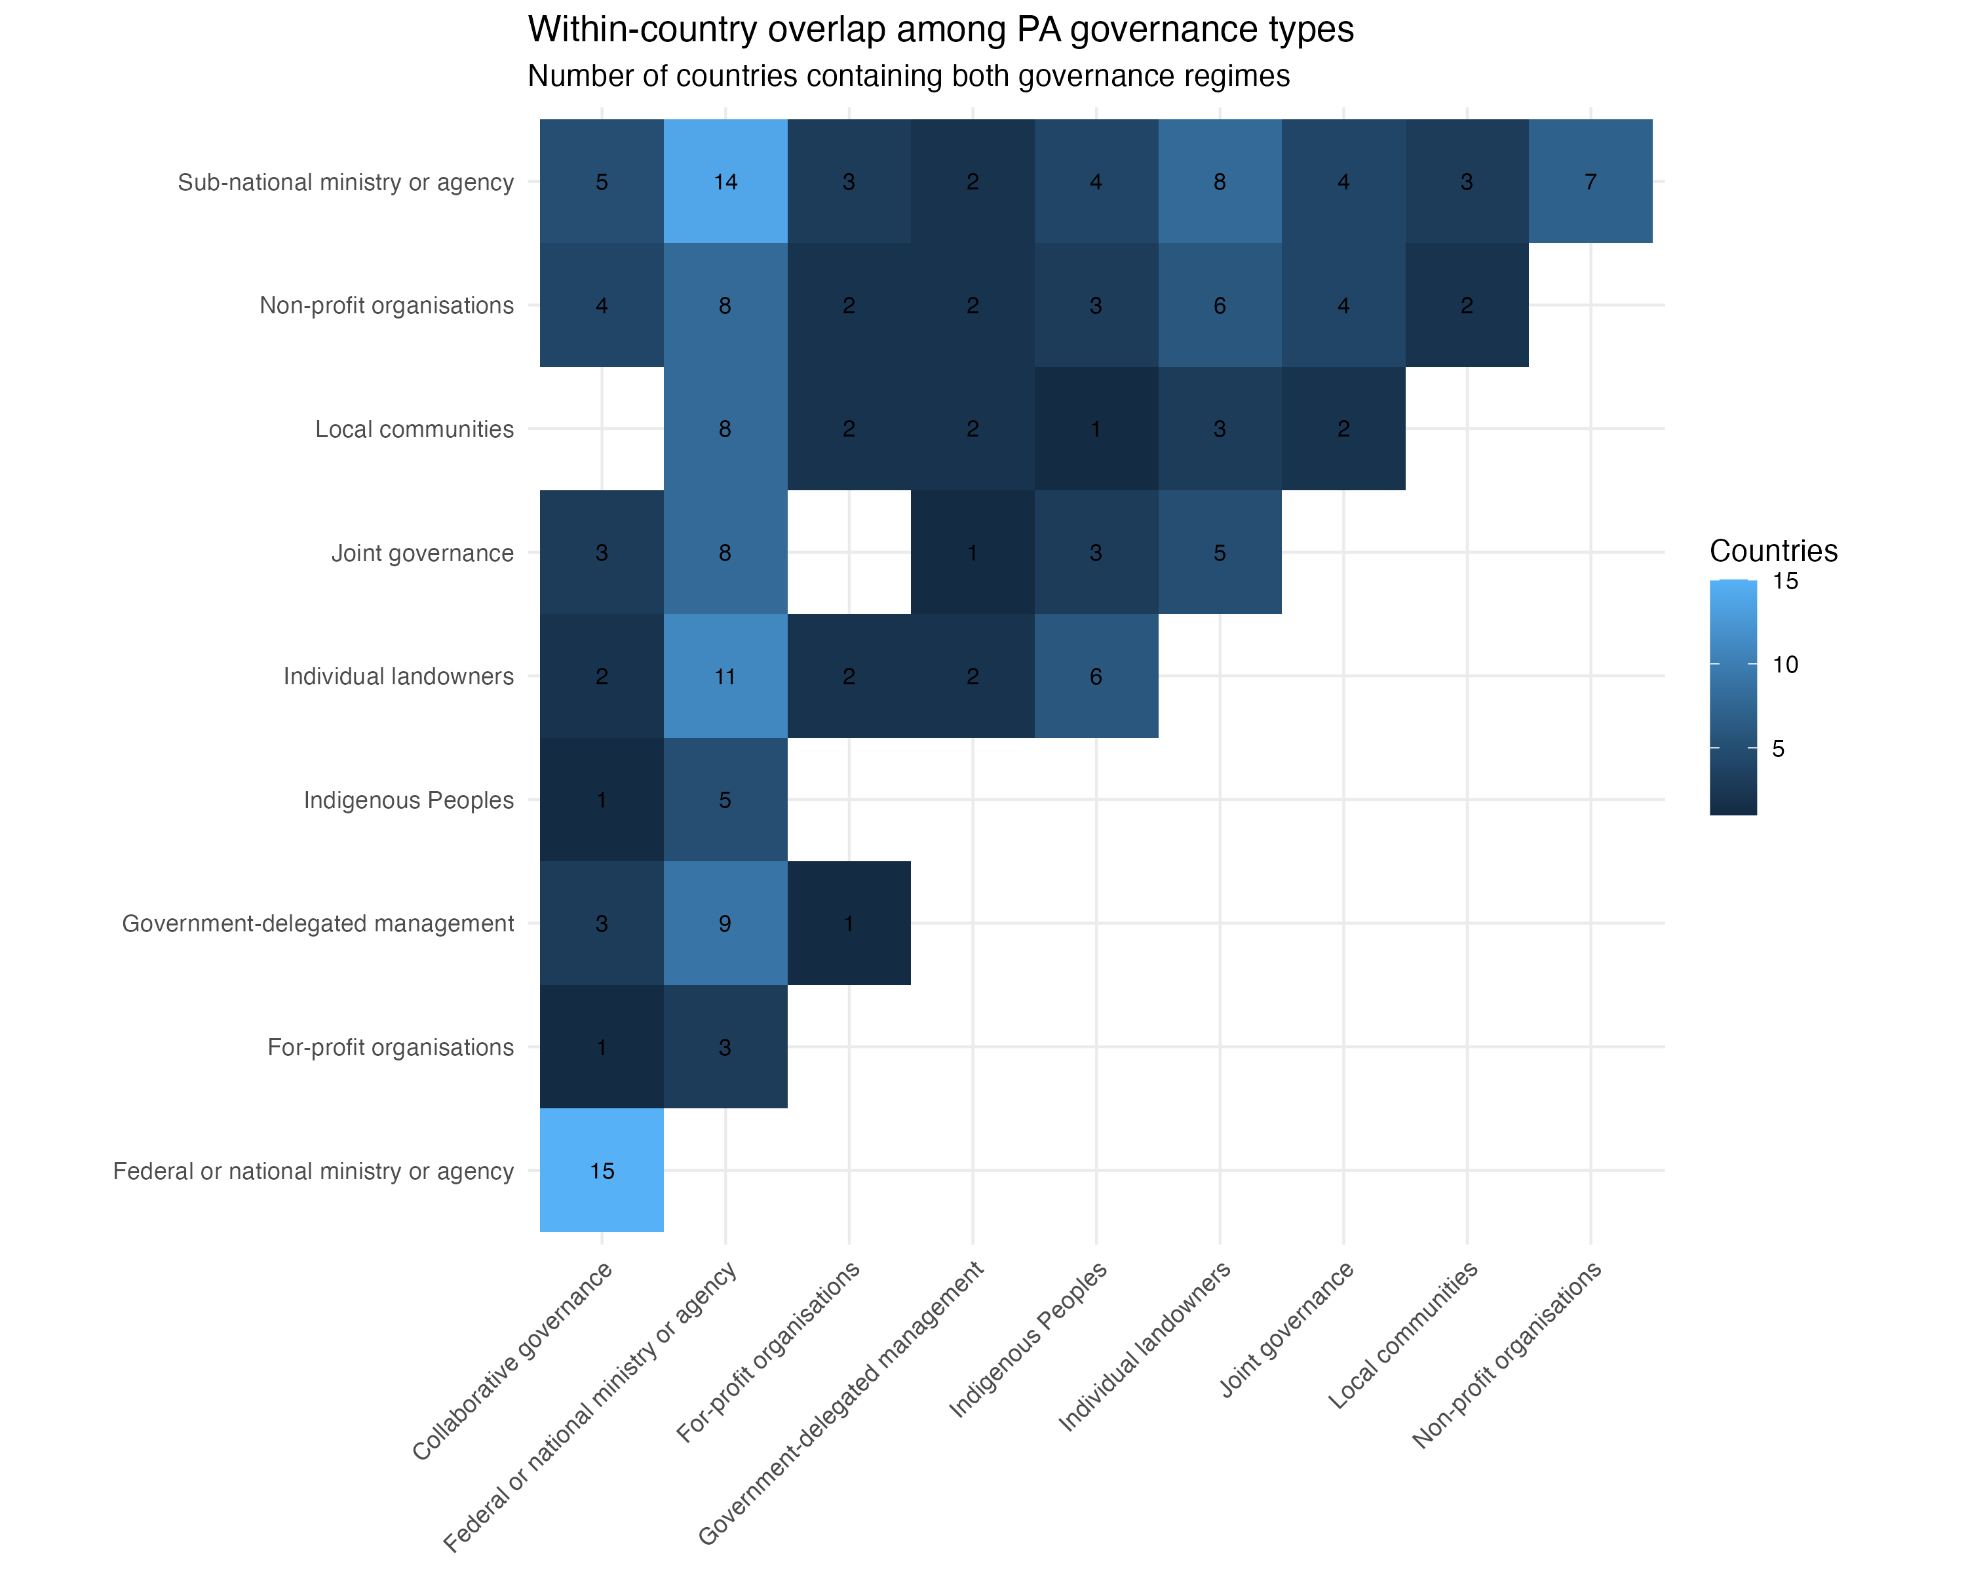

Table A2.9a. Pairwise within-country overlap among IUCN categories
IUCN category A | IUCN category B | Countries containing both
II | IV | 62
III | IV | 47
IV | VI | 47
IV | V | 46
II | VI | 44
II | III | 39
III | V | 39
II | V | 35
Ia | IV | 31
Ib | IV | 29
Ib | II | 28
III | VI | 26
Ia | II | 26
V | VI | 26
Ia | III | 22
Ib | III | 22
Ib | VI | 22
Ia | V | 21
Ia | VI | 21
Ib | V | 19
Ia | Ib | 14

A2.9b. Within-country overlap heatmaps for IUCN category.